4.2 & 4.3 Double Integrals Worksheet

- Integrate over the domain D, where D is the region bounded by .

- Find the volume of the solid that is bounded above by the cylindrical surface and below by the domain enclosed by the parabola and the line .

- Use a double integral to determine the area of the region given by which exists above the x-axis.

- A cylindrical drill bit is used to bore a vertical hole through the center of the solid bounded above by the graph of and bounded below by the region in the xy-plane given by . What is the radius of the drill bit if 10% of the volume of the solid is removed?

- The integral has the form when converted into polar coordinates.
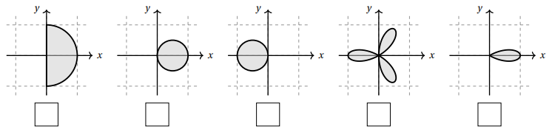
  - Mark the box below with the picture of the region that represents R.

  - Fill in the missing integrand to convert this integral into polar coordinates.

- Determine the volume of the region that lies under the sphere , above the plane and inside the cylinder .

- Use a double integral to determine the area of the region bounded by the curves and on the interval from .

- Evaluate the integral .

